<page_start no = 1>
<sol_start id=1>
1. (3)
<sol_end>

<sol_start id=2>
2. No solution
<sol_end>

<sol_start id=3>
3. 10 units
<sol_end>

<sol_start id=4>
4. Proportional
<sol_end>

<sol_start id=5>
5.
<sol_end>

<sol_start id=6>
6. x³ y³
<sol_end>

<sol_start id=7>
7. Sem of zeroes = their product
α + β = αβ
8 = 2k – 8
2k = 16
k = 8
<sol_end>
<page_end>

<page_start no = 2>
<sol_start id=8>
8 AB² = AC² (because it can equable al ∆^{1e})
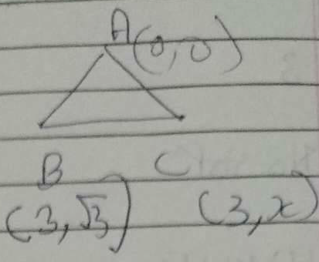
(3–0²) + +
⇒
x =
<sol_end>

<sol_start id=9>
9. 2px + 3y = 7
2x + y = 0
(Given)
2P ≠ 6
P ≠ 6
<sol_end>

<sol_start id=10>
10. PD||BC
AP/PB = AD/DC (B.P.T) → (1)
Ad/DC = CE /BE (Given) → (2)
(From (1) & (2))
by converse of BPT
DE//AC
<sol_end>
<page_end>

<page_start no = 3>
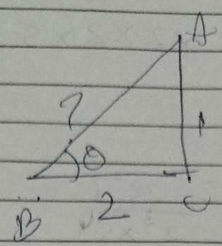
<sol_start id=11>
11.
AB² = AC² + BC²
= 1 + 4
= 5
AB =
sin θ =
cos θ =
Hence proved
<sol_end>

<sol_start id=12>
12. 5000 = 2 × 2 × 2 × 5 × 5 × 5 × 5
⇒
= 0.0514
<sol_end>
<sol_start id=13>
13.
let is first assure that
is rational and is the form p/q and q = O
(p/q are co-prime integers)
Square on both sides
3q² = p²
⇒ 3 is a factor of p²
3 is a factor of p also
p = 3k
square on both sides
p² = 6k²
3 q² = 9k²
q² = 3k²
⇒ 3 is a factor of q³
∴ 3 is a factor of q also
3 is now the factor of both p and q
This contradicts our statement that p/q are co-prime integers
∴ is an irrational us
<sol_end>
<page_end>

<page_start no = 4>
<sol_start id=14>
14. α + β =
αβ =
=
Also
x² +
49 x² + 18x + 4 = 0
<sol_end>

<sol_start id=15>
15.
– 5 (a + 1) = 3 (1 – 2a)
a = 8
9b = 10 b – 5
b = 5
<sol_end>

<sol_start id=16>
16. Given ∆ABE ≅ ∆ACD
AB = AC (C. PCT) →(1)
AE = AP (CP.CT) →(2)
Dividing (2) by (1)
In ∆ADE & ∆ABC
∠A = ∠A (coupon)
(proved)
By SAS criterion
∆ADE ~ ∆ABC
Hence proved
<sol_end>

<sol_start id=17>
17.
= RHS
Hence proved
<sol_end>
<page_end>

<page_start no = 5>
<sol_start id=19>
19. Let the fraction be
(Given)
2x = y + 1
y = – 9
∴ The fraction is
<sol_end>

<sol_start id=20>

20. BPT start that, if a line parallel to a side of a triangle it intersects the other 2 sides than the line divides it unto equal proportion
ABC be a ∆ i_{e}
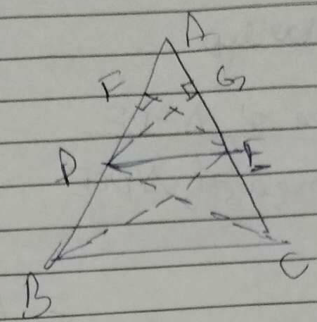
BC||DE
To prove
Join BE, CD
Construction : EF⊥AB , DG⊥CA
∴ Area of ∆ADE =
=
Area of ∆PBE =
→ (1)
Similarly
=
=
∆DBE and ∆DCE have the same base b’w same parallels
∴
<sol_end>

<sol_start id=21>
21.
⇒
<sol_end>
<page_end>

<page_start no = 6>
<sol_start id=23>
23. Time (one round) covered by = = 6 min
Time (one round) covered by B = = 10 min
Time (one round) covered by C = = 9 min
A,B,C meet after time t and completed n₁ , n₂ , n₃ rounds respectively
330 t = x + 1980 n₁ ---(1)
198 t = x + 1980 n₂ ----(2)
Substituting x into (2) & (3)
198 t = 330 t – 1980 n₁ + 1980 n²
1980 (n₁ – n₂) = 132t
t = 15 (n – n₂)
Also , 220t = 330t – 1980 n₁ + 1980 n₂
1980 (n₁ – n₃) = 110t
t = (n₁ – n₃)
Since t is same and n₁ – n₃ and n₁ – n₂ can be whole no.
LCM of 15 and 15 and 18 is 90
A,B,C will meet after 90 mins
<sol_end>

<sol_start id=24>
24. (2y + x = 70) ×2 Father’s age be x Son’s age be y
22 + y = 95
⇒ 3 y = 45
y = 15
15 + 2x = 95
2x = 80
x = 40
Father’s age 40
Son's age 15
<sol_end>

<sol_start id=25>
25. (6,4) and (1,–7) be divided by the point on x axis (x,0)
Let us assume the ratio to be k : 1
(section formula)
–7k + 4 = 0
m : n ⇒ ⇒ 4 : 7
m + n = 4 + 7 = 11
W.K.T
Diagonals of a ||^{gm} bisect each other.
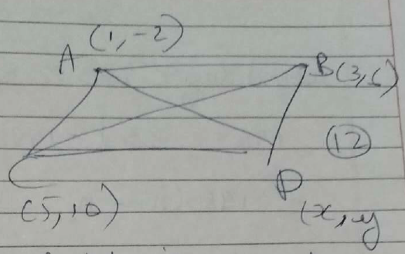
So the midpoint of AC is same of mid point of BD
AC BD
=
=
3 + x = 6 ; 6 + y = 3
x = 3 ; y = 2
So forth vertex’s coordinates are (3,2)
<sol_end>
<page_end>

<page_start no = 7>
<sol_start id=28>
28. D of PR =
=
= 3, –1
<sol_end>

<sol_start id=29>
29. Relative speed x – y (same direction)
Dist = (x – y)5
(100)
x – y = 20
x + y (oppilate direction)
x + y = 100
2x = 120
x = 60 km/h
y = 40 km/h
<sol_end>

<sol_start id=30>
30. ∆ABD ~ ∆PQD (corresponding sides are parallel)
---(1)
∆CDB ~ PQB (corresponding sides are parallel)
---(2)
Hence prover
<sol_end>
<page_end>

